**CHAPTER 5 DETAILS OF DESIGNS, WORKING AND PROCESS**

**5.1 Introduction**

It is a process of collecting and interpreting facts, identifying the problems, and decomposition of a system into its component.System analysis is conducted for the purpose of studying a system or its parts in order to identify its objectives. It is a problem solving technique that improves the system and ensures that all the components of the system work efficiently to accomplish their purpose.

Analysis specifies what the system should do. It is a process of planning a new business system or replacing an existing system by defining its components or modules to satisfy the specific requirements. Before planning, you need to understand the old system thoroughly and determine how computers can best be used in order to operate efficiently.System Design focuses on how to accomplish the objective of the system

**5.2 System Analysis**

Systems analysis is the process of examining a business situation for the purpose of developing a system solution to a problem or devising improvements to such a situation. Before the development of any system can begin, a project proposal is prepared by the users of the potential system and/or by systems analysts and submitted to an appropriate managerial structure within the organization

**5.2.1 Introduction to System analysis**

It is a process of collecting and interpreting facts, identifying the problems, and decomposition of a system into its components. System analysis is conducted for the purpose of studying a system or its parts in order to identify its objectives. It is a problem solving technique that improves the system and ensures that all the components of the system work efficiently to accomplish their purpose. Analysis specifies what the system should do.

**5.2.2 Software Design approach**

The incremental build model is a method of software development where the model is designed, implemented and tested incrementally (a little more is added each time) until the product is finished. It involves both development and maintenance. The product is defined as finished when it satisfies all of its requirements. This model combines the elements of the waterfall model with the iterative philosophy of prototyping. The product is decomposed into a number of components, each of which are designed and built separately (termed as builds). Each component is delivered to the client when it is complete. This allows partial utilization of product and avoids a long development time. It also creates a large initial capital outlay with the subsequent long wait avoided. This model of development also helps ease the traumatic effect of introducing completely new system all at once

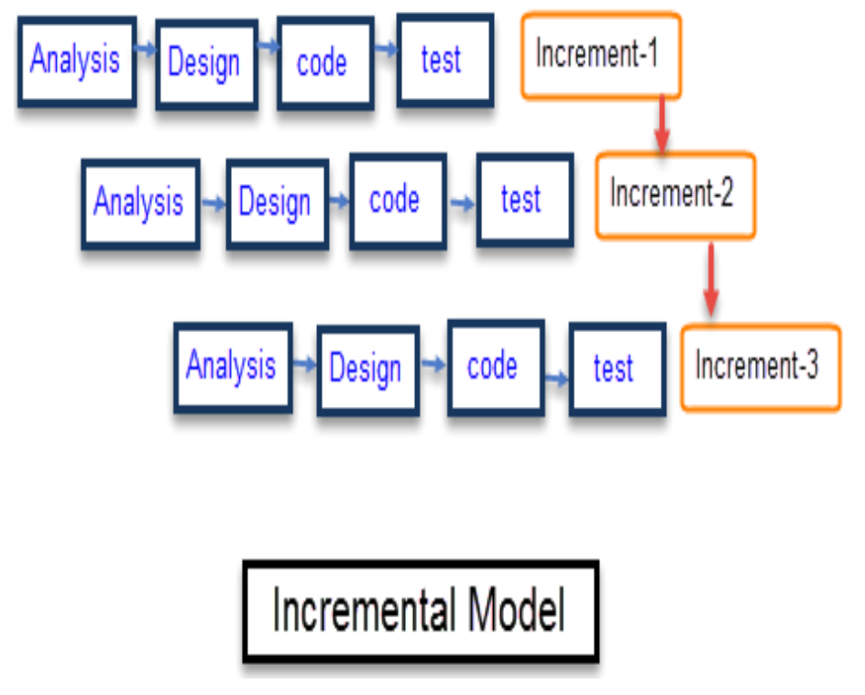

**Figure 5.1: Iterative and Incremental Model**

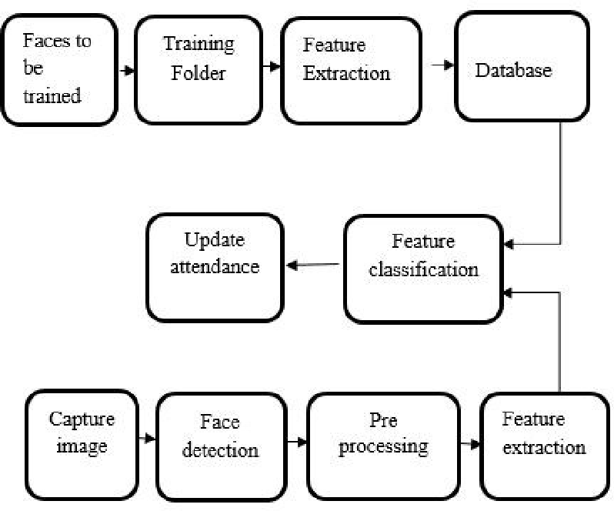

**Figure 5.2: Block Diagram**

**5.4 Timeline Chart**

A timeline chart is an effective way to visualize a process using chronological order. Since details are displayed graphically, important points in time can be easy seen and understood.

Often used for managing a project’s schedule, timeline charts function as a sort of calendar of events within a specific period of time.

A Timeline chart is constructed with a horizontal axis representing the total time span of the project, broken down into increments (for example, days, weeks, or months) and a vertical axis representing the tasks that make up the project (for example, if the project is outfitting your computer with new software, the major tasks involved might be: conduct research, choose software, install software). Horizontal bars of varying lengths represent the sequences, timing, and time span for each task. Using the same example, you would put "conduct research" at the top of the vertical axis and draw a bar on the graph that represents the amount of time you expect to spend on the research, and then enter the other tasks below the first one and representative bars at the points in time when you expect to undertake them.

The bar spans may overlap, as, for example, you may conduct research and choose software during the same time span. As the project progresses, secondary bars, arrowheads, or darkened bars may be added to indicate completed tasks, or the portions of tasks that have been completed. A vertical line is used to represent the report date.

**5.5 Cost Estimation**

Cost estimation is an approximation of the probable cost of a product, program, or project, computed on the basis of available information.

**Four common types of cost estimates are:**

1) Planning estimate: a rough approximation of cost within a reasonable range of values, prepared for information purposes only. Also called ball park estimate.

2) Budget estimate: an approximation based on well-defined (but preliminary) cost data and established ground rules.

3) Firm estimate: a figure based on cost data sound enough for entering into a binding contract.

4) Not-to-exceed /Not-less-than estimate: the maximum or minimum amount required to accomplish a given task, based on a firm cost estimate.

The four basic steps in software project estimations are:   
1) Estimate the size of the development product.

2) Estimate the effort in person-months or persons-hours.

3) Estimate the schedule in calendar months.

4) Estimate the project cost in agreed currency.

Factors in calculating cost estimation:

• Total number of weeks in 5th semester= 14

• Total number of weeks in 6th semester= 16

• Number of hours spent in developing project= 10 hrs (per week)

Cost estimation of the proposed system:

Total number of weeks= Weeks in 5th semester + Weeks in 6th semester =

14 + 16

Total number of weeks = 30 weeks.

Total number of hours = Total num. of weeks * Num. of hours spent per week

=30*10

Total number of hours = 300 hours.

Cost Estimation= Total number of hours * Cost per hour

=300 *40

Cost Estimation = Rs. 12,000.

Total Cost Estimation of Proposed System= Rs. 12,000.

**5.6 Feasibility Study**

A feasibility study is used to determine the viability of an idea, such as ensuring a project is legally and technically feasible as well as economically justifiable. It tells us whether a project is worth the investment, in some cases, a project may not be doable. There can be many reasons for this, including requiring too many resources, which not only prevents those resources from performing other tasks but also may cost more than an organization would earn back by taking on a project that isn’t profitable.

The importance of a feasibility study is based on organizational desire to “get it right” before committing resources, time, or budget. A feasibility study might uncover new ideas that could completely change a project’s scope. Conducting a feasibility study is always beneficial to the project as it gives you and other stakeholders a clear picture of the proposed project.

**Five Areas of Project Feasibility:**

A feasibility study evaluates the project’s potential for success; therefore, perceived objectivity is an important factor in the credibility of the study for potential investors and lending institutions. There are five types of feasibility study as follows:

* Technical Feasibility - It helps organizations determine whether the technical resources meet capacity and whether the technical team is capable of converting the ideas into working systems. Technical feasibility also involves evaluation of the hardware, software, and other technology requirements of the proposed system.
* Economic Feasibility - This assessment typically involves a cost/ benefits analysis of the project, helping organizations determine the viability, cost, and benefits associated with a project before financial resources are allocated. It also serves as an independent project assessment and enhances project credibility, helping decision makers determine the positive economic benefits to the organization that the proposed project will provide.
* Legal Feasibility - This assessment investigates whether any aspect of the proposed project conflicts with legal requirements like zoning laws, data protection acts, or social media laws. Let’s say an organization wants to construct a new office building in a specific location. A feasibility study might reveal the organization’s ideal location isn’t zoned for that type of business.
* Operational Feasibility - This assessment involves undertaking a study to analyse and determine whether and how well the organization’s needs can be met by completing the project. Operational feasibility studies also analyse how a project plan satisfies the requirements identified in the requirements analysis phase of system development.
* Scheduling Feasibility - This assessment is the most important for project success; after all, a project will fail if not completed on time. In scheduling feasibility, an organization estimates how much time the project will take to complete.

**5.7 DFD & UML**

**Data Flow Diagram**

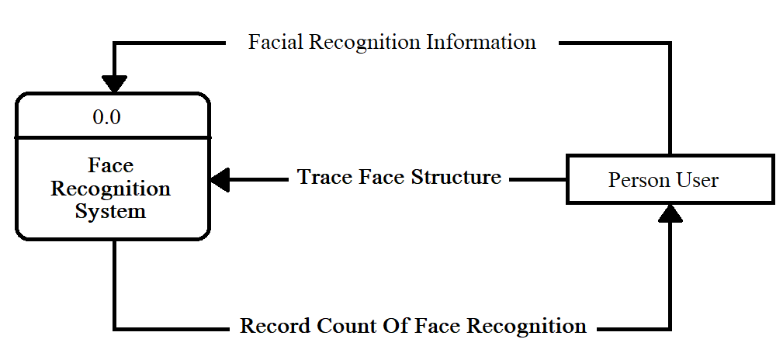

**Figure 5.4 Zero Level DFD**